

**PATTERN PROCESSING USING AI**

**PRACTICAL FILE**

**Name: Chirag Gupta**

**Roll No.: 2019UCO1689**

**Subject Code: COCSE60**

1. **Write a python program to implement a simple Chatbot.**

Code:

import random

responses = {

"hello": ["Hi there!", "Hello!", "Hey!"],

"how are you": ["I'm doing well, thank you.", "Not too bad, thanks for asking.", "I'm just fine."],

"what's your name": ["My name is Chatbot.", "I go by Chatbot.", "You can call me Chatbot."],

"default": ["I'm sorry, I didn't understand what you said.", "Can you please rephrase that?", "I'm not sure what you mean."],

}

def get_response(user_input):

user_input = user_input.lower().strip()

if user_input in responses:

return random.choice(responses[user_input])

else:

return random.choice(responses["default"])

def run_chatbot():

print("Hi, I'm Chatbot. How can I help you today?")

while True:

user_input = input("You: ")

bot_response = get_response(user_input)

print("Chatbot: " + bot_response)

if user_input.lower().strip() == "bye":

print("Chatbot: Goodbye!")

break

run_chatbot()

Output:

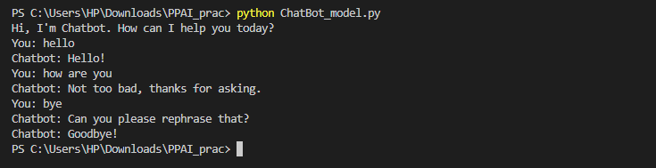

1. **Write a program to implement k-means clustering from scratch.**

Code:

import numpy as np

import matplotlib.pyplot as plt

from sklearn.preprocessing import StandardScaler

from numpy.random import uniform

from sklearn.datasets import make_blobs

import seaborn as sns

import random

def euclidean(point, data):

"""

Euclidean distance between point & data.

Point has dimensions (m,), data has dimensions (n,m), and output will be of size (n,).

"""

return np.sqrt(np.sum((point - data)**2, axis=1))

class KMeans:

def __init__(self, n_clusters=8, max_iter=300):

self.n_clusters = n_clusters

self.max_iter = max_iter

def fit(self, X_train):

self.centroids = [random.choice(X_train)]

for _ in range(self.n_clusters-1):

# Calculate distances from points to the centroids

dists = np.sum([euclidean(centroid, X_train) for centroid in self.centroids], axis=0)

# Normalize the distances

dists /= np.sum(dists)

# Choose remaining points based on their distances

new_centroid_idx, = np.random.choice(range(len(X_train)), size=1, p=dists)

self.centroids += [X_train[new_centroid_idx]]

iteration = 0

prev_centroids = None

while np.not_equal(self.centroids, prev_centroids).any() and iteration < self.max_iter:

# Sort each datapoint, assigning to nearest centroid

sorted_points = [[] for _ in range(self.n_clusters)]

for x in X_train:

dists = euclidean(x, self.centroids)

centroid_idx = np.argmin(dists)

sorted_points[centroid_idx].append(x)

prev_centroids = self.centroids

self.centroids = [np.mean(cluster, axis=0) for cluster in sorted_points]

for i, centroid in enumerate(self.centroids):

if np.isnan(centroid).any():

self.centroids[i] = prev_centroids[i]

iteration += 1

def evaluate(self, X):

centroids = []

centroid_idxs = []

for x in X:

dists = euclidean(x, self.centroids)

centroid_idx = np.argmin(dists)

centroids.append(self.centroids[centroid_idx])

centroid_idxs.append(centroid_idx)

return centroids, centroid_idxs

centers = 5

X_train, true_labels = make_blobs(n_samples=100, centers=centers, random_state=42)

X_train = StandardScaler().fit_transform(X_train)

# Fit centroids to dataset

kmeans = KMeans(n_clusters=centers)

kmeans.fit(X_train)

class_centers, classification = kmeans.evaluate(X_train)

sns.scatterplot(x=[X[0] for X in X_train],

y=[X[1] for X in X_train],

hue=true_labels,

style=classification,

palette="deep",

legend=None

)

plt.plot([x for x, _ in kmeans.centroids],

[y for _, y in kmeans.centroids],

'k+',

markersize=10,

)

plt.show()

Output:

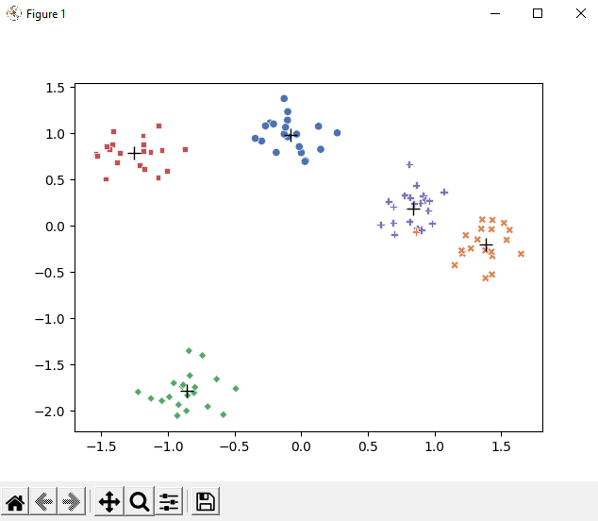

1. **Generating samples of Gaussian (normal) distributions and plotting them for visualisation**

Code:

import numpy as np

import matplotlib.pyplot as plt

mean1, mean2, mean3 = 0, 5, -5

std1, std2, std3 = 1, 2, 3

data1 = np.random.normal(mean1, std1, 1000)

data2 = np.random.normal(mean2, std2, 1000)

data3 = np.random.normal(mean3, std3, 1000)

fig, ax = plt.subplots()

ax.hist(data1, bins=50, alpha=0.5, label='Data 1')

ax.hist(data2, bins=50, alpha=0.5, label='Data 2')

ax.hist(data3, bins=50, alpha=0.5, label='Data 3')

ax.legend(loc='upper right')

ax.set_title('Gaussian Distribution Samples')

ax.set_xlabel('Value')

ax.set_ylabel('Frequency')

plt.show()

Output:

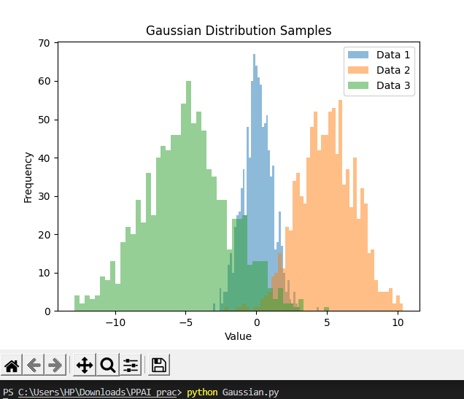

1. **Implement Decision Tree algorithms.**

Code:

import numpy as np

from sklearn.datasets import load_iris

from sklearn.model_selection import train_test_split

class DecisionTree:

def __init__(self, max_depth=5, min_samples_split=2):

self.max_depth = max_depth

self.min_samples_split = min_samples_split

def fit(self, X, y):

class Node:

def __init__(self, feature_idx=None, threshold=None, left=None, right=None, is_leaf=False, label=None):

self.feature_idx = feature_idx

self.threshold = threshold

self.left = left

self.right = right

self.is_leaf = is_leaf

self.label = label

def entropy(y):

_, counts = np.unique(y, return_counts=True)

p = counts / len(y)

return -np.sum(p * np.log2(p))

def info_gain(X, y, feature_idx, threshold):

left_idx = X[:, feature_idx] < threshold

left_y = y[left_idx]

right_y = y[~left_idx]

p_left = len(left_y) / len(y)

p_right = 1 - p_left

ig = entropy(y) - p_left * entropy(left_y) - p_right * entropy(right_y)

return ig

def split(X, y, depth):

if depth >= self.max_depth or len(X) < self.min_samples_split or len(np.unique(y)) == 1:

label = np.bincount(y).argmax()

return Node(is_leaf=True, label=label)

best_feature_idx, best_threshold, best_ig = None, None, 0

for feature_idx in range(X.shape[1]):

thresholds = np.unique(X[:, feature_idx])

for threshold in thresholds:

ig = info_gain(X, y, feature_idx, threshold)

if ig > best_ig:

best_feature_idx, best_threshold, best_ig = feature_idx, threshold, ig

left_idx = X[:, best_feature_idx] < best_threshold

right_idx = ~left_idx

left_node = split(X[left_idx], y[left_idx], depth+1)

right_node = split(X[right_idx], y[right_idx], depth+1)

return Node(feature_idx=best_feature_idx, threshold=best_threshold, left=left_node, right=right_node)

self.root = split(X, y, depth=0)

def predict(self, X):

def traverse(node, x):

if node.is_leaf:

return node.label

if x[node.feature_idx] < node.threshold:

return traverse(node.left, x)

else:

return traverse(node.right, x)

y_pred = np.array([traverse(self.root, x) for x in X])

return y_pred

iris = load_iris()

X, y = iris.data, iris.target

X_train, X_test, y_train, y_test = train_test_split(X, y, test_size=0.3, random_state=42)

dt = DecisionTree()

dt.fit(X_train, y_train)

y_pred = dt.predict(X_test)

accuracy = np.sum(y_pred == y_test) / len(y_test)

print("Accuracy:", accuracy)

Output:



1. **Implement SVM.**

Code:

import numpy as np

from sklearn.datasets import load_iris

from sklearn.model_selection import train_test_split

import matplotlib.pyplot as plt

class SVM:

def __init__(self, learning_rate=0.001, regularization=0.01, num_iterations=1000):

self.lr = learning_rate

self.reg = regularization

self.num_iters = num_iterations

self.w = None

self.b = None

def fit(self, X, y):

self.w = np.zeros(X.shape[1])

self.b = 0

for i in range(self.num_iters):

margins = y * (np.dot(X, self.w) + self.b)

hinge_loss = np.maximum(0, 1 - margins)

dw = self.reg * self.w - np.dot(X.T, y * (hinge_loss > 0))

db = -np.sum(y * (hinge_loss > 0))

self.w -= self.lr * dw

self.b -= self.lr * db

def predict(self, X):

scores = np.dot(X, self.w) + self.b

return np.sign(scores)

iris = load_iris()

X = iris.data[:, :2] # Select only the first two features

y = np.where(iris.target == 0, -1, 1) # Convert labels to -1 or 1

X_train, X_test, y_train, y_test = train_test_split(X, y, test_size=0.2)

svm = SVM()

svm.fit(X_train, y_train)

x_min, x_max = X[:, 0].min() - 1, X[:, 0].max() + 1

y_min, y_max = X[:, 1].min() - 1, X[:, 1].max() + 1

xx, yy = np.meshgrid(np.arange(x_min, x_max, 0.02),

np.arange(y_min, y_max, 0.02))

Z = svm.predict(np.c_[xx.ravel(), yy.ravel()])

Z = Z.reshape(xx.shape)

plt.contourf(xx, yy, Z, cmap=plt.cm.Paired, alpha=0.8)

plt.scatter(X_train[:, 0], X_train[:, 1], c=y_train, cmap=plt.cm.Paired)

plt.xlabel('Sepal length')

plt.ylabel('Sepal width')

plt.xlim(xx.min(), xx.max())

plt.ylim(yy.min(), yy.max())

plt.xticks(())

plt.yticks(())

plt.show()

Output:

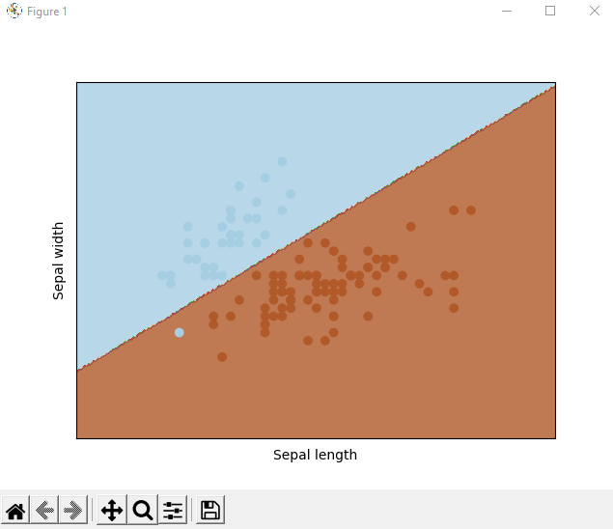

1. **Implement Principal component analysis and use it for unsupervised learning**

Code:

import numpy as np

def pca(X, num_components):

mean_X = np.mean(X, axis=0)

X_centered = X - mean_X

cov_X = np.cov(X_centered, rowvar=False)

eigenvalues, eigenvectors = np.linalg.eigh(cov_X)

sorted_indices = np.argsort(eigenvalues)[::-1]

sorted_eigenvalues = eigenvalues[sorted_indices]

sorted_eigenvectors = eigenvectors[:, sorted_indices]

top_eigenvectors = sorted_eigenvectors[:, :num_components]

X_transformed = np.dot(X_centered, top_eigenvectors)

return X_transformed, top_eigenvectors

from sklearn.datasets import load_iris

iris = load_iris()

X = iris.data

X_transformed, top_eigenvectors = pca(X, num_components=2)

from sklearn.cluster import KMeans

kmeans = KMeans(n_clusters=3, random_state=42)

kmeans.fit(X_transformed)

labels = kmeans.labels_

import matplotlib.pyplot as plt

plt.scatter(X_transformed[:, 0], X_transformed[:, 1], c=labels)

plt.xlabel('Principal Component 1')

plt.ylabel('Principal Component 2')

plt.show()

Output:

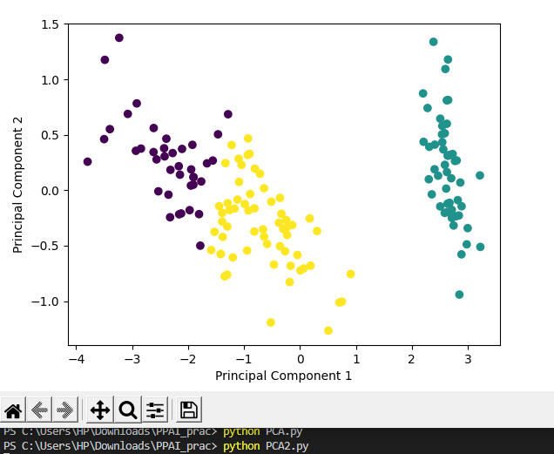

1. **Implement Maximum-Likelihood estimation.**

Code:

import numpy as np

def likelihood(x, mu, sigma):

n = len(x)

log_likelihood = -n/2*np.log(2*np.pi*sigma**2) - np.sum((x-mu)**2)/(2*sigma**2)

return log_likelihood

def d_likelihood_mu(x, mu, sigma):

n = len(x)

d_log_likelihood_mu = np.sum((mu-x)/(sigma**2))

return d_log_likelihood_mu

def d_likelihood_sigma(x, mu, sigma):

n = len(x)

d_log_likelihood_sigma = -n/(2*sigma**2) + np.sum((x-mu)**2)/(2*sigma**4)

return d_log_likelihood_sigma

def maximum_likelihood_estimation(x):

mu = np.mean(x)

sigma = np.std(x)

alpha = 0.1

epsilon = 1e-5

while True:

d_mu = d_likelihood_mu(x, mu, sigma)

d_sigma = d_likelihood_sigma(x, mu, sigma)

mu -= alpha*d_mu

sigma -= alpha*d_sigma

if np.abs(d_mu) < epsilon and np.abs(d_sigma) < epsilon:

break

return mu, sigma

np.random.seed(123)

x = np.random.normal(loc=5, scale=2, size=100)

mu, sigma = maximum_likelihood_estimation(x)

print('mu:', mu)

print('sigma:', sigma)

Output:



1. **Implement agglomerative Hierarchical clustering.**

Code:

import numpy as np

import matplotlib.pyplot as plt

from sklearn.datasets import load_iris

class AgglomerativeClustering:

def __init__(self, n_clusters):

self.n_clusters = n_clusters

def fit(self, X):

clusters = [[i] for i in range(X.shape[0])]

dist_matrix = np.zeros((X.shape[0], X.shape[0]))

for i in range(X.shape[0]):

for j in range(i+1, X.shape[0]):

dist_matrix[i,j] = np.linalg.norm(X[i,:] - X[j,:])

dendrogram = np.zeros((X.shape[0]-1, 4))

for i in range(X.shape[0]-1):

min_dist = np.inf

for j in range(len(clusters)):

for k in range(j+1, len(clusters)):

dist = np.min(dist_matrix[clusters[j],:][:,clusters[k]])

if dist < min_dist:

min_dist = dist

merge_clusters = (j,k)

dendrogram[i,0] = merge_clusters[0]

dendrogram[i,1] = merge_clusters[1]

dendrogram[i,2] = min_dist

dendrogram[i,3] = len(clusters[merge_clusters[0]]) + len(clusters[merge_clusters[1]])

clusters[merge_clusters[0]] += clusters[merge_clusters[1]]

del clusters[merge_clusters[1]]

# Update the distance matrix

for j in range(len(clusters)-1):

for k in range(j+1, len(clusters)):

min_dists = []

for l in clusters[j]:

for m in clusters[k]:

min_dists.append(dist_matrix[l,m])

dist_matrix[j,k] = min(min_dists)

dist_matrix[k,j] = dist_matrix[j,k]

self.labels_ = np.zeros(X.shape[0], dtype=np.int32)

for i in range(X.shape[0]):

for j in range(dendrogram.shape[0]):

if dendrogram[j,0] <= i < dendrogram[j,3]:

self.labels_[i] = j + X.shape[0] - self.n_clusters

break

self.dendrogram = dendrogram

def plot_dendrogram(self):

# Plot the dendrogram

plt.figure(figsize=(10,6))

plt.title('Dendrogram')

plt.xlabel('Observations')

plt.ylabel('Distance')

plt.xticks([])

plt.yticks([])

for i in range(self.dendrogram.shape[0]):

x1 = self.dendrogram[i,0]

x2 = self.dendrogram[i,1]

y1 = self.dendrogram[i,2]

y2 = self.dendrogram[i,3]

plt.plot([x1,x1,x2,x2], [y1,y2,y2,y1], 'k-')

plt.show()

iris = load_iris()

X = iris.data

n_clusters = 3

model = AgglomerativeClustering(n_clusters)

model.fit(X)

model.plot_dendrogram()

print(model.labels_)

Output:

